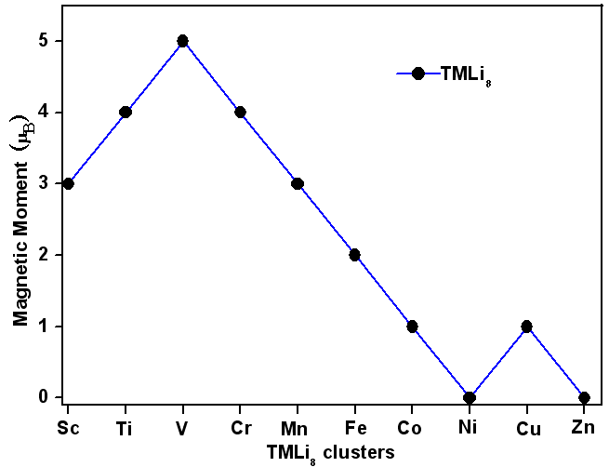
Figure 9. Magnetic trends of TMLi₈ (TM=Sc, Ti, V, Cr, Mn, Fe, Co, Ni, Cu, and Zn) clusters for the lowest-energy structures.

